**ETL Extraction – Example of Loading FCT_\***

Task 02. Prepare Table of Facts to DW Layer

User DW_CL was granted with necessary privileges which were added in attached file init_users.sql.

Tables on DW Layer were created by running scripts from directory \dw\tables\.

Package pkg_etl_fct_finances_dw was created to reload data in different fact tables at DW Layer from source tables:

- sa_finance.gdp_countries,

- sa_finance. finance_countries,

- sa_finance.fact_financing.

Package pkg_etl_fct_finances_dw (presented in directory \dw_cl\packages\) consists of the next procedures:

1**. Load_gdp_countries**- to load data about GDP of countries in table dw.t_gdp_countries. Result of procedure execution is presented below.

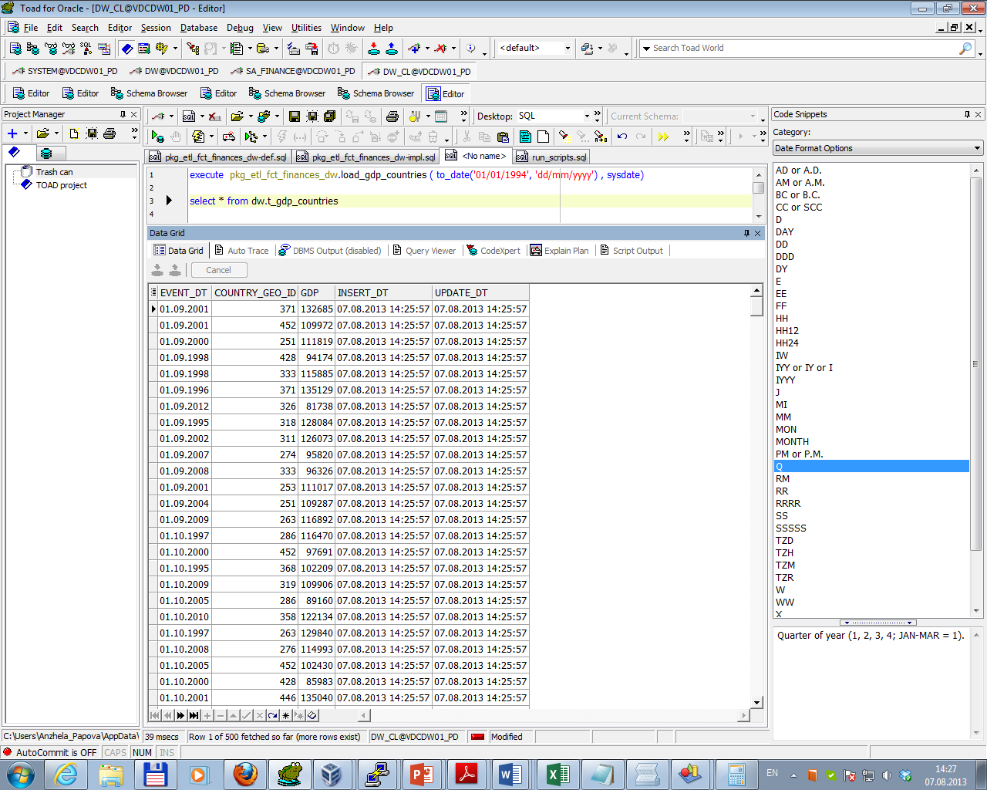

After multi execution result accords business requirements (BR11): data for previous 12 months was overwritten (and update date was changed):

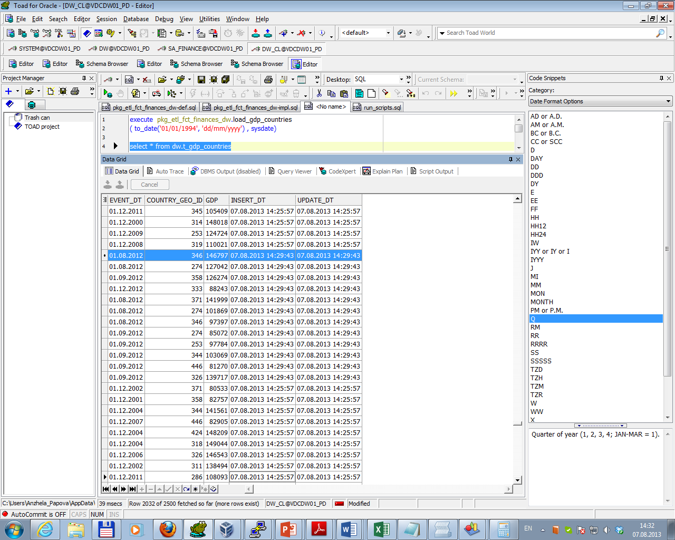

2**. Load_finance_countries** - to load data about budget revenues and expenses of countries in table dw.t_finance_countries. Result of procedure execution is presented below.

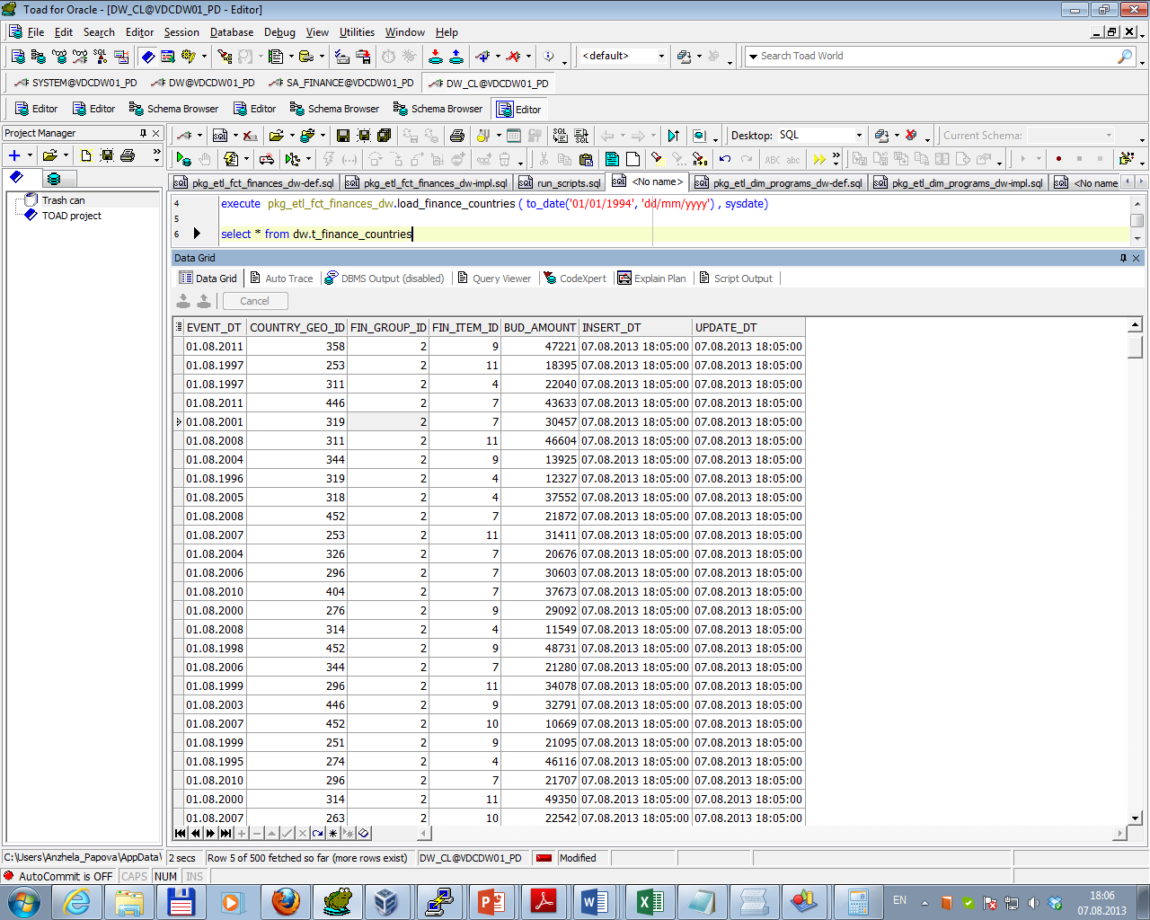

After multi execution result accords business requirements (BR11): data for previous 12 months was overwritten (and update date was changed):

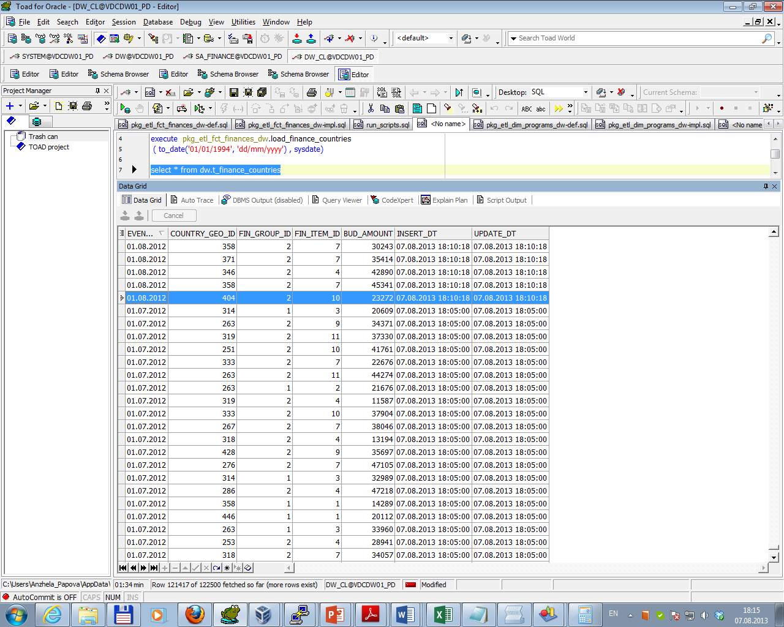

3**. Load_fact_financing**- to load data about fact funding of countries in table dw.t_fact_financing. Result of procedure execution is presented below.

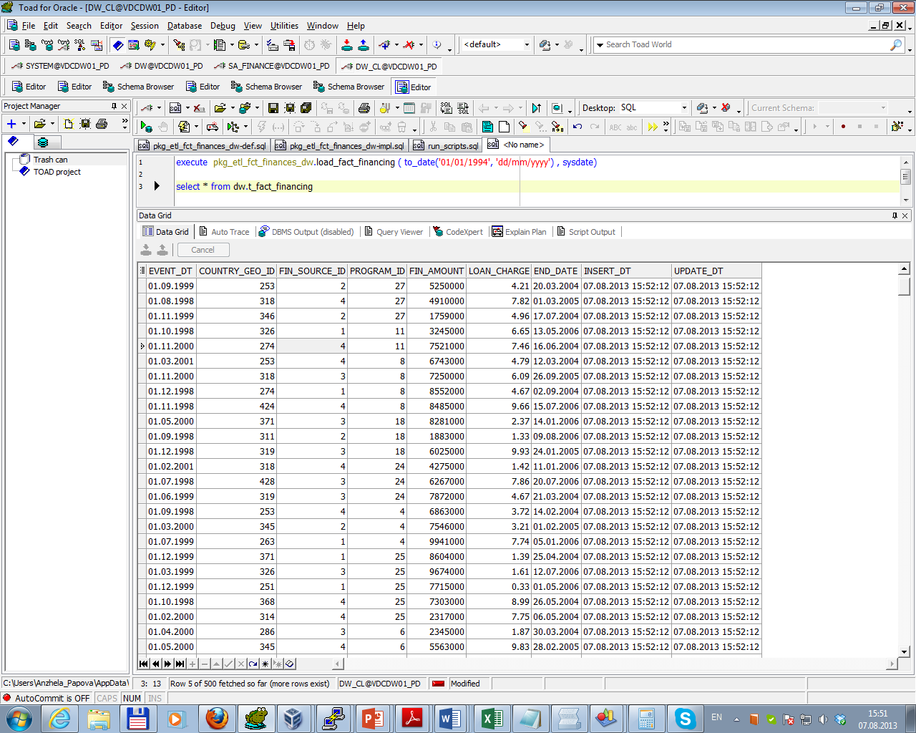

After multi execution result accords business requirements (BR11): data for previous 12 months should be overwritten (as data for this period doesn’t exist there are no changes).